**ORIGINAL ITEM - 1**

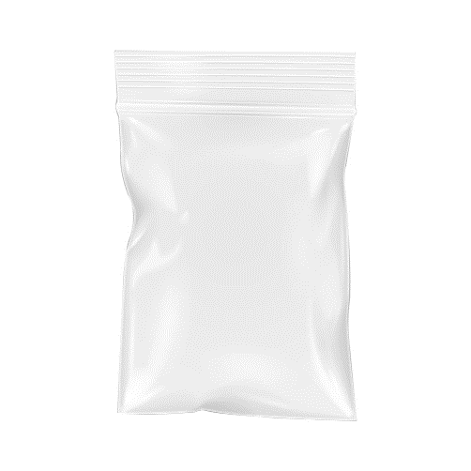

**WEIGHTED RECOMMENDATIONS (51, 40, 4, 0.7, 0.4)**

|  |  |  |  |  |
| --- | --- | --- | --- | --- |
| **Not Available** | image | image | image | image |

**NON-WEIGHTED RECOMMENDATIONS (11, 8.5, 8.5, 7, 5.7)**

|  |  |  |  |  |
| --- | --- | --- | --- | --- |
|  |  |  |  |  |

**ORIGINAL ITEM – 2**

**WEIGHTED RECOMMENDATIONS**

|  |  |  |  |  |
| --- | --- | --- | --- | --- |
|  |  |  |  |  |

**NON-WEIGHTED RECOMMENDATIONS**

|  |  |  |  |  |
| --- | --- | --- | --- | --- |
|  |  |  |  |  |

**ORIGINAL ITEM – 3**

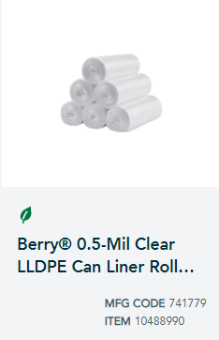

**WEIGHTED RECOMMENDATIONS**

|  |  |  |  |  |
| --- | --- | --- | --- | --- |
|  |  |  |  |  |

**NON-WEIGHTED RECOMMENDATIONS**

|  |  |  |  |  |
| --- | --- | --- | --- | --- |
|  |  |  |  |  |

**­­­­­­**

**ORIGINAL ITEM – 4**

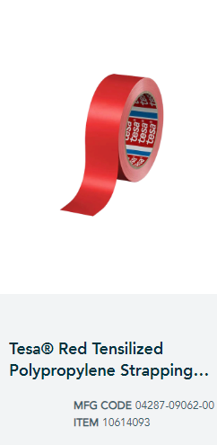

**­­­**

**WEIGHTED RECOMMENDATIONS**

|  |  |  |  |  |
| --- | --- | --- | --- | --- |
|  |  |  |  |  |

**NON-WEIGHTED RECOMMENDATIONS**

|  |  |  |  |  |
| --- | --- | --- | --- | --- |
|  |  |  |  |  |

**ORIGINAL ITEM – 5**

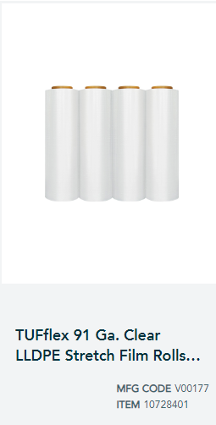

**WEIGHTED RECOMMENDATIONS**

|  |  |  |  |  |
| --- | --- | --- | --- | --- |
|  |  |  |  |  |

**NON-WEIGHTED RECOMMENDATIONS**

|  |  |  |  |  |
| --- | --- | --- | --- | --- |
|  |  |  |  |  |

**ORIGINAL ITEM – 6**

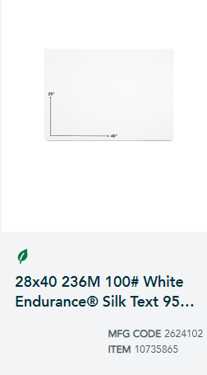

**WEIGHTED RECOMMENDATIONS**

|  |  |  |  |  |
| --- | --- | --- | --- | --- |
|  |  |  |  |  |

**NON WEIGHTED RECOMMENDATIONS**

|  |  |  |  |  |
| --- | --- | --- | --- | --- |
|  |  |  |  |  |

**ORIGINAL ITEM – 7**

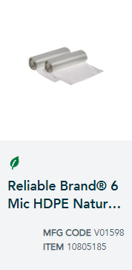

**WEIGHTED RECOMMENDATIONS**

|  |  |  |  |  |
| --- | --- | --- | --- | --- |
|  |  |  |  |  |

**NON-WEIGHTED RECOMMENDATIONS**

|  |  |  |  |  |
| --- | --- | --- | --- | --- |
|  |  |  |  |  |

**ORIGINAL ITEM – 8**

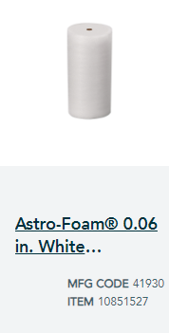

**WEIGHTED RECOMMENDATIONS**

|  |  |  |  |  |
| --- | --- | --- | --- | --- |
|  |  |  |  |  |

**NON-WEIGHTED RECOMMENDATIONS**

|  |  |  |  |  |
| --- | --- | --- | --- | --- |
|  |  |  |  |  |

**ORIGINAL ITEM – 9**

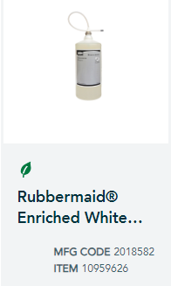

**WEIGHTED RECOMMENDATIONS**

|  |  |  |  |  |
| --- | --- | --- | --- | --- |
|  |  |  |  |  |

**NON-WEIGHTED RECOMMENDATIONS**

|  |  |  |  |  |
| --- | --- | --- | --- | --- |
| Stretch film- 10728697 |  |  |  |  |

**ORIGINAL ITEM – 10**

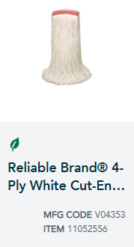

**WEIGHTED RECOMMENDATIONS**

|  |  |  |  |  |
| --- | --- | --- | --- | --- |
|  |  |  |  |  |

**NON-WEIGHTED RECOMMENDATIONS**

|  |  |  |  |  |
| --- | --- | --- | --- | --- |
|  |  |  |  |  |

**ORIGINAL ITEM – 11**

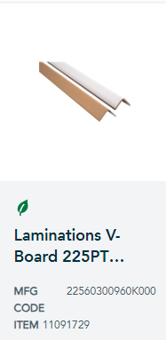

**WEIGHTED RECOMMENDATIONS**

|  |  |  |  |  |
| --- | --- | --- | --- | --- |
|  |  |  |  |  |

**NON-WEIGHTED RECOMMENDATIONS**

|  |  |  |  |  |
| --- | --- | --- | --- | --- |
|  |  |  |  |  |